Sample project

Database

User database  
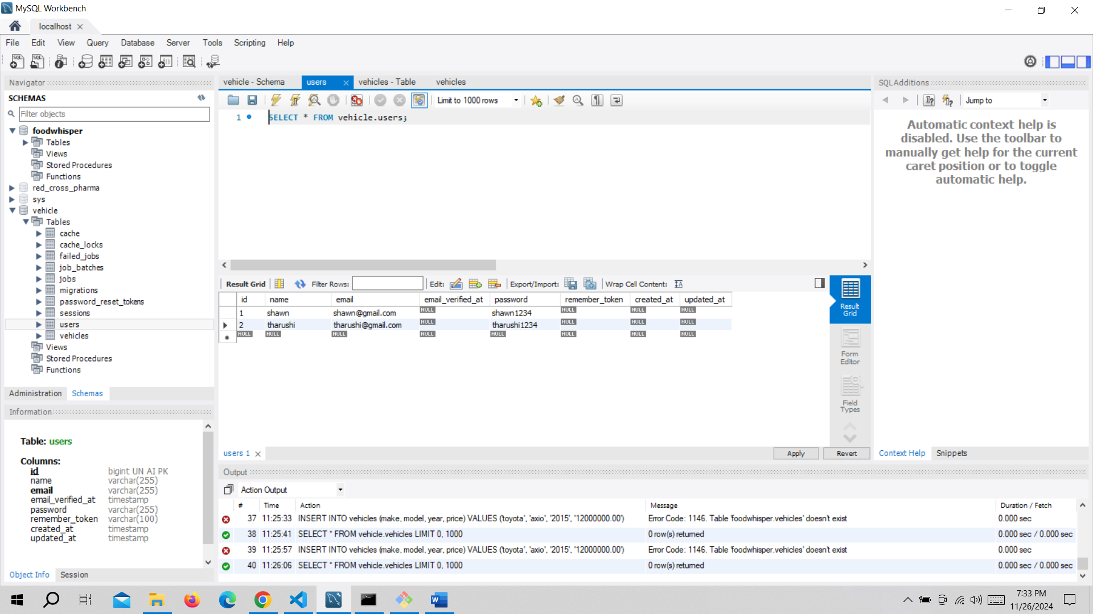

Vehicles database

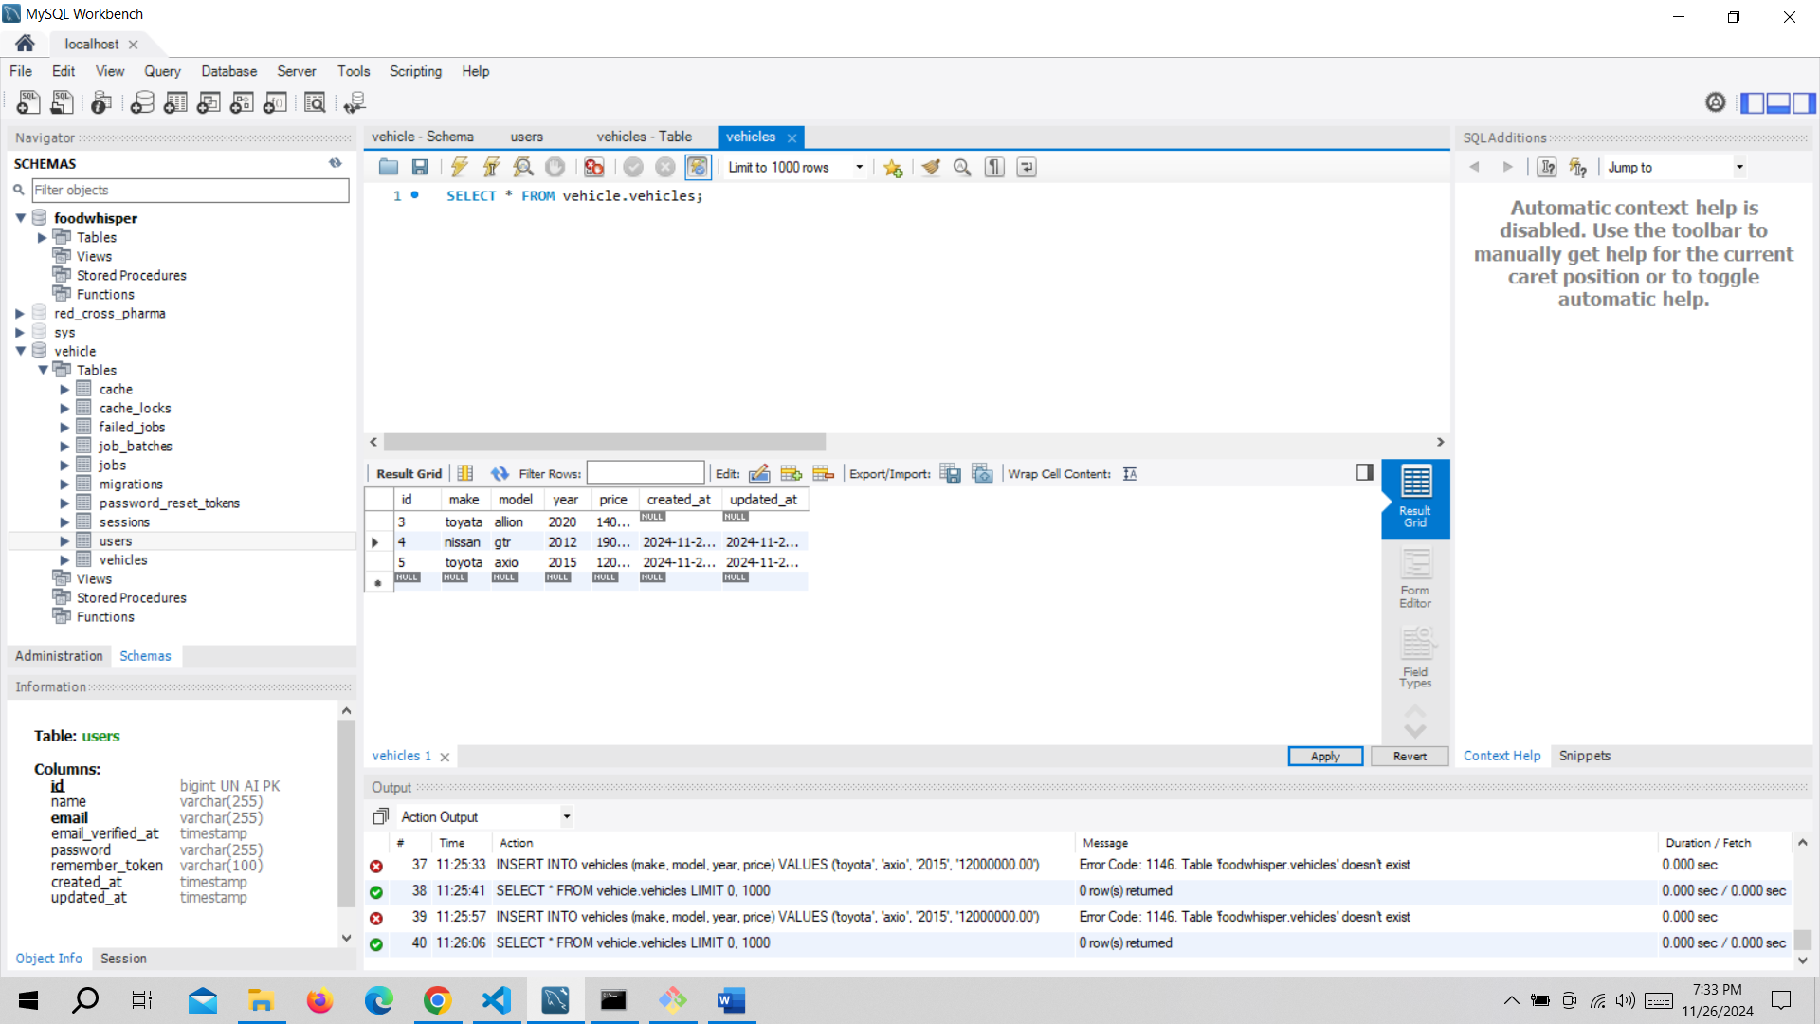

1st page the main dashboard the total vehicles and the total users are shown in the dashboard. and also, the add car details form is shown that adds the car details to the database

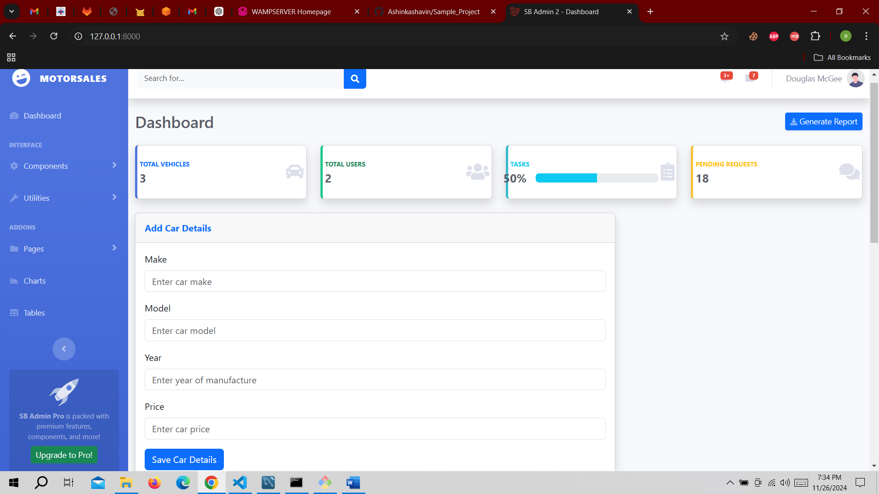

The second page that shows the details of the case in a table and also have given a delete option so that when ever needed the row can be deleted.

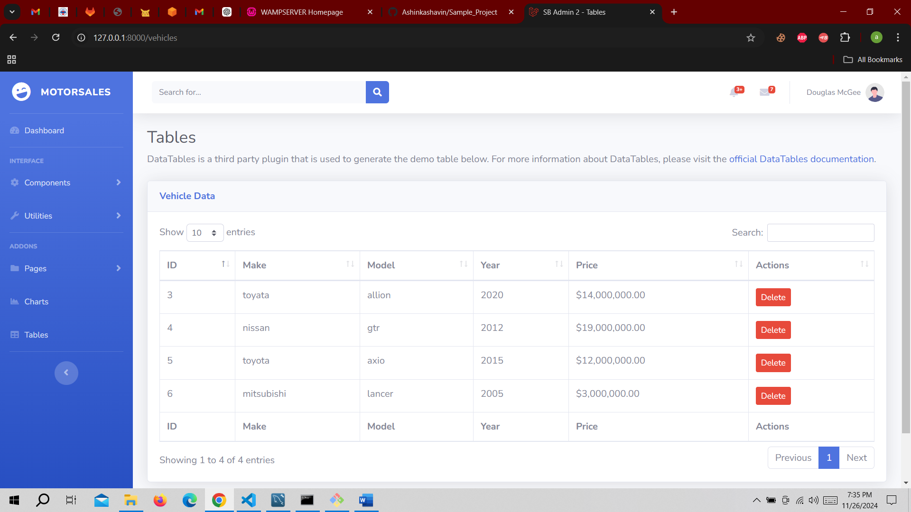

Validation when the details are saved successfully are shown in the form

